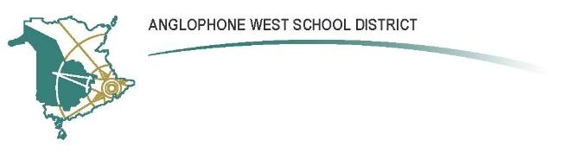
Nashwaaksis Middle School
324 Fulton Avenue, Fredericton NB E3A 5J4
Parent School Support Committee
AGENDA
Date: October 9, 2019 Time: 7:00 - 7:40 pm
Location: Nashwaasksis Middle School
PSSC Members Present:  Jennifer Welles  Michelle Mills  Dan Mills  Jamie Campbell  Vivek Virmani  Krista Merrill  PSSC Members Regrets:  Melissa Awad  Melissa McCallum  Jonathan Keizer (Co-Chair) - TBC  Jessica McNeil – TBC | School/DEC Representation Present:  - Kendra Frizzell, Principal  Regrets:  - John Hickey, Teacher representative  School/DEC Representation Regrets:  - Sean Winslow, DEC

Call to Order: 7:05
Review and Approval of Agenda: n/a (Initial meeting)
Approval of Minutes from Previous Meeting: n/a (Initial meeting)
Business Arising from the Minutes: n/a (Initial meeting)
Principal’s Report n/a (Initial meeting)
New Business:
- Discussed the role of the PSSC. Focus on advising the Principal on the School Improvement Plan
- Discussed general function of meetings, and agreed to keep standard agenda format. Meetings will be held on Tuesdays beginning at 7:15 pm, on the following dates:
  - November 26, 2019
  - January 28, 2020
  - February 25, 2020
  - March 31, 2020
  - April 28, 2020
  - May 26, 2020
- Dan Mills will serve as Secretary, replacing Carolin Galvin
- Jennifer Welles will continue as PSSC Chair
- Items for next meeting will include:
  - Review the current School Improvement Plan
  - Discuss budget for 2019-20
Correspondence: None
Closing Comments: Thanks to all for serving on the PSSC this year.
Date of next meeting: November 26, 2019 at 7:15
Adjournment: 7:40 pm

